CRM – Common errors and best practices

Solution problems
solutions can cause problems, some common problems are
- CRM 2011 – Solution not importing – Timeout errors
Increase the OLEDBTimeout and the ExtendedTimeout
- CRM 2011 – SQL error while importing solution in crm 2011
Error can be because of mismatch in data type of the field.
To resolve the error you have to delete the variable in the CRM organisation you are trying to import the solution to. Then you will be able to import the solution.
The best way to find the variable is to use WinMerge and compare the customization.xml files in the previous solution file and the new solution customization.xml. You can get the solution file by exporting it if you don’t have one to hand.
- CRM2011 OptionSetId Cannot be Changed when Importing Unmanaged Solution
When working with unmanaged solution at some point I decided some of the Option Sets should change from entity level to global option sets.
It failed, it gave the error – ‘OptionSetId’ cannot be changed’ when importing. It took me a while to work out which option set was causing me problems but in the end I removed and deleted most of them until I got the right one.
- CRM 2011 – error when importing solution
Error: The solution file is invalid.
The compressed file must contain the following files at its root: solution.xml, customizations.xml, and [Content_Types].xml
The problem was I was zipping up the solution folder; this then creates a zip file with a folder at the root and then the three solution files.
Solution: What you have to do is select the three xml files and then zip them up. This then it doesn’t create the root folder.
Reason for error during import can be related to permissions.
Solution:
“Import Customizations” permission. “Import Customizations” and “Import Job” permissions are required to import and install solutions in CRM. Make sure it is set to Organization.
- How to delete components from managed solution in Dynamics CRM?

There can be requirements to delete the components from the managed solution. Neither directly deleting the components from managed solution works nor deleting the field from unmanaged solution and migrating as managed solution to target environment works.
We can make use of OOB feature of solution management.OOB feature used is Clone the solution. The version of the solution will be upgraded when we clone the solution.

Steps:
Steps to be followed are given below:
- Delete the components from your unmanaged solution that are not required or replaced.
- Make note of Version Number and click on Clone Solution.
- You can check the Version Number. It is increased by 1 count (It was 1.0.0.0, now it’s 1.1.0.0). Click on Save
- 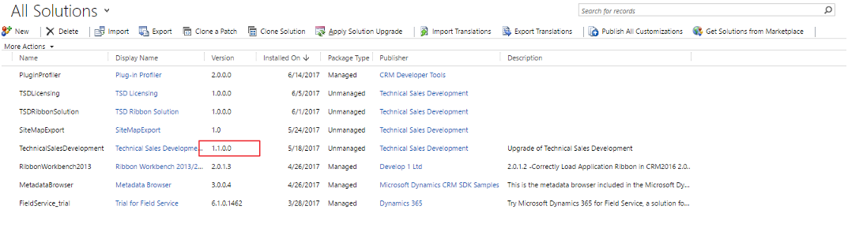
- Export the solution as managed and import on the target environment
- While importing this solution, make sure that you checked “Stage for Upgrade”
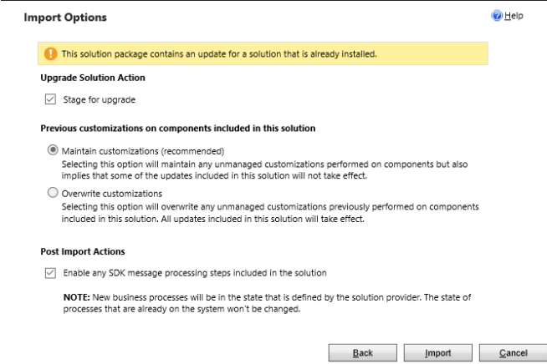

SSRS REPORTS IN CRM
https://www.youtube.com/watch?v=pRLSDvlHezk

All about CRM
https://www.youtube.com/watch?v=b819UmiKDUA

CRM Ribbon customization
https://www.powerobjects.com/2012/07/09/guide-for-crm-2011-ribbon-customization/

https://www.youtube.com/watch?v=BAalZIDp3cg

PlugIn basics, development , deployment
https://community.dynamics.com/365/b/softchiefmicrosoftdynamics365/archive/2016/11/12/dynamics-365-crm-plug-ins
PlugIn context- https://msdn.microsoft.com/en-us/library/gg309673.aspx#bkmk_inputandoutput

https://www.youtube.com/watch?v=gxFtZd1BPKw
https://www.youtube.com/watch?v=G_WPaHZZk7k
Chk with karthik….
- Where to look for PI request or response? - DeleteRequest
- for deployment using solution
https://crmbook.powerobjects.com/extending-crm/plug-in-development-and-workflow-extensions/plug-ins/registering-and-deploying-plug-ins/
Debug PI
- https://www.youtube.com/watch?v=zTM2l-J6opk
- https://dynamics365blocks.wordpress.com/2016/12/06/how-to-debug-a-plugin-in-dynamics-365-online-using-plugin-profiler/

Deploying Plugins with the Microsoft Dynamics CRM 2011 Developer Toolkit (alternate for PI Reg tool)
http://eimagine.com/how-to-deploying-plugins-with-the-microsoft-dynamics-crm-2011-developer-toolkit-tutorial/

Plugins Secure and UnSecure Configurations

https://www.youtube.com/watch?v=ZVzwHG_VA6k
https://www.youtube.com/watch?v=edOwzUJ30kk

Action in Dynamics CRM
https://www.youtube.com/watch?v=ON3k5cy23Fc

CRM - Custom Actions

https://www.youtube.com/watch?v=-V9nAF2cjJA

Web Resources
https://www.youtube.com/watch?v=R76ZVZ9L8Ns

Business Rules
https://www.youtube.com/watch?v=U59pJZ2rm-g

Becoming a D365 developer
https://www.youtube.com/watch?v=FnWugHDVPi4

How to Consume the External Web API or Webservices from Dynamics 365(CRM)Plugin

https://www.youtube.com/watch?v=jDuR8YbSkGo

How to Update a Record with Xrm.WebApi In Dynamics 365 v9.x

https://www.youtube.com/watch?v=dJ-m0MIvdmY

XRM Tool box usage
https://www.youtube.com/watch?v=TSN2oVKnjM0

JavaScript Development
https://www.youtube.com/watch?v=wxMB-cIQPUw
https://www.youtube.com/watch?v=nDRJk_33sa8
https://www.youtube.com/watch?v=Ztha5urjKQg
Debug JS- https://www.youtube.com/watch?v=CL2hvOMvg9c

Business Rules in Dynamics CRM 2016
https://www.youtube.com/watch?v=Q7CrKDztt5I

MS CRM 2015 Integration with Web Application(ASP.Net) and Retrieving Data and showing in Grid
https://www.youtube.com/watch?v=0SgQ7Z1MANU&t=10s

Product Name | Version | Code Name
Fall 2017 ? | ?? | Calcium
July 2017 ? | 9.0 | Potassium
365 Dec 2016 | 8.2 | Centaurus
2016 SP1 and Spring 2016 | 8.1 | Naos
2016 | 8.0 | Ara
2015 (Online only) | 7.1 | Carina
2015 | 7.0 | Vega
2013 SP1 and Spring 14 | 6.1 | Leo
2013 | 6.0 | Orion
2011 (Online only) | 5.0 | Polaris
2011 | 5.0
4.0 | 4.0 | Titan

